The Lord’s Prayer.
Trusting in the compassion of God, as our Saviour taught us, so we pray
All: Our Father in heaven, hallowed be your name, your kingdom come, your will be done, on earth as in heaven. Give us today our daily bread. Forgive us our sins as we forgive those who sin against us. Lead us not into temptation but deliver us from evil. For the kingdom, the power, and the glory are yours now and forever. Amen.

In peace we will lie down and sleep;
All for you alone, Lord, make us dwell in safety.
Abide with us, Lord Jesu
All for the night is at hand and the day is now past.
As the night watch looks for the morning,
All so do we look for you, O Christ.
Come with the dawning of the day
All and make yourself known in the morning light.
May God bless us, that in us may be found love and humility, obedience and thanksgiving, discipline, gentleness and peace, Amen.

Some of today’s questions may have raised issues that you would like to talk about further. We are both always happy to chat with you further in private.

ST CUTHBERTS AND THE ANNUNCIATION
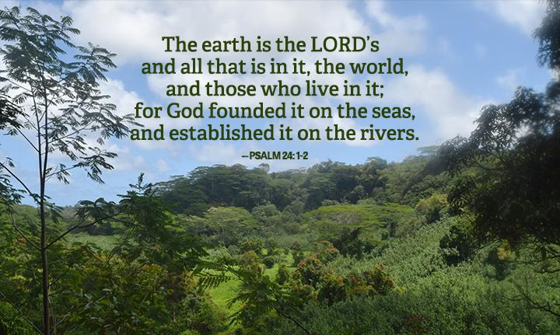

ECO-LENT HOUSEGROUP

17th FEBRUARY 19:30pm

Week 1: Introduction ECO-LENT 2021

Psalm 24 - Health

A Psalm of David.

The earth is the Lord’s, and everything in it, the world, and all who live in it; for he founded it on the seas and established it on the waters.
Who may ascend the mountain of the Lord? Who may stand in his holy place?
The one who has clean hands and a pure heart, who does not trust in an idol or swear by a false god.

They will receive blessing from the Lord and vindication from God their Saviour. Such is the generation of those who seek him, who seek your face, God of Jacob.

Lift up your heads, you gates; be lifted up, you ancient doors, that the King of glory may come in.
Who is this King of glory?
The Lord strong and mighty,
the Lord mighty in battle.
Lift up your heads, you gates.
lift them up, you ancient doors,
that the King of glory may come in.

Who is he, this King of glory? The Lord Almighty—
he is the King of glory.
Psalm 24; 1 – 10
This year for lent we will be looking at the book “SAYING YES TO LIFE” written by Ruth Valerio. This book was the Archbishop of Canterbury's 2020 Lent book. The creation and our care of God’s world is very high on the agenda of the Church. We are all need to think seriously about how we look after Gods beautiful creation, we need to think about the damage each and every one of us is causing each and every day. This damage affects the health of others, it affects the lives of many animals around the world, and it affects the environment that we all live in. It is often the poorest people on our planet that have to pay the cost of the environmental damage that we all cause. This Lent may we pray that God will change our will our words our thinking and our actions.

The books intro talks about Fiji and how the climate disaster is affecting the people of that island right now. So often we think that the climate disaster will happen in the future and that we have time. If we are called to love our neighbour we are called to act now.

Questions:
The earth is the Lord’s, and everything in it, the world, and all who live in it.

- So often our focus as Christians is on eternity and not the world we live in now. As we think about this verse from Psalm 24 what do you think our attitude should be to the world?

Who may ascend the mountain of the Lord? Who may stand in his holy place? The one who has clean hands and a pure heart, who does not trust in an idol or swear by a false god.

- What do you think it means to have clean hands and a pure heart?

They will receive blessing from the Lord and vindication from God their Saviour. Such is the generation of those who seek him, who seek your face, God of Jacob.

- This part of the Psalm talks about having a saviour how can we be saved from this current environmental dilemma do you feel there is any hope?

Lift up your heads, you gates; be lifted up, you ancient doors, that the King of glory may come in. Who is this King of glory? The Lord strong and mighty,
the Lord mighty in battle.
Lift up your heads, you gates.
lift them up, you ancient doors,
that the King of glory may come in.

Who is he, this King of glory? The Lord Almighty— he is the King of glory.

- So often we can look at the world and see no hope only impending disaster, but God wants us to place our trust in him that in Jesus Christ the creator of all things everything is possible. Do you feel there is hope for our world that our environmental disaster can be reversed?

Reflections:
Can you think of any other people in the bible who argued with God?

Psalm 103:
The LORD is compassionate and gracious, slow to anger, abounding in love.

1 John 4: 8
Anyone who does not love does not know God, because God is love.

Prayers:;
A time of shared and silent prayer for the concerns of our lives, our community, and our world.

