Annunciation Day

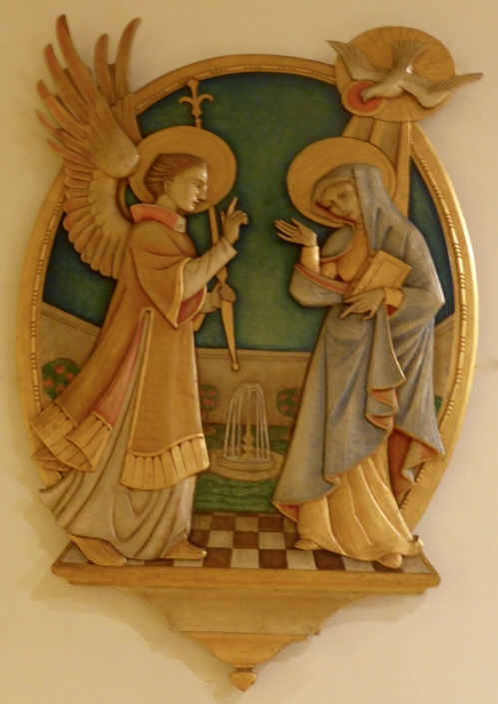

‘Tell out my soul the greatness of the Lord’

Festival of The Annunciation

Mary – Greek name meaning ‘wise lady’

Mary’s Faith – a questioning faith: Luke 1:26-37, the Annunciation

Mary encounters the Angel Gabriel who tells her astounding news. She is chosen to bear the Son of God. She is not thinking of objections. Her faith is practical – she doesn’t doubt the Angel or his message. She does though challenge the practical side of the message– ‘how, since I have not had relations with a man?’
Faith is never just about blind assent. It is not divorced from questioning, but as we see with Mary, faith is strengthened by questioning.

Prayer time:
What faith questions do you have? Spend a moment telling God what they are.

Now think of the people around us who will have faith questions. Ask God to help us be a church where people feel safe to ask questions and pray that your faith and the faith of others will be strengthened through being free to ask questions. Pray especially for the monthly coffee mornings.

Mary’s faith – a faith that chooses to take the leap Luke 1: 29 & 38

Mary doesn’t have the answer to all her questions. She was ‘greatly troubled’ after listening to the angel. Even after giving birth there is plenty she is unsure of, but she just holds everything in her heart, prepared to play the waiting game and see what God would do. She knows it will not be an easy journey from the start – a social outcast, a promise of her own soul being pierced, prior knowledge of the experience of many prophets from the past - plenty of reasons to hold back. But faith doesn’t have to hold all the answers to exist. Like taking the plunge to start any new experience, none of us has all the answers when we choose to ‘go for it’. Mary goes for it with
God – she brings all her questions with her and literally commits her life into God’s hands.

“May it be done unto me according to your word.”

We are also reminded that she could have chosen not to follow the calling God offered. She could have said no, but freely chose to say yes to her God.

Prayer time:
Are you willing to take that same leap of faith with God?
Faith is an ongoing journey – an ongoing series of saying ‘yes’.

Ask God to give you a renewed willingness to ‘go for it’ with your faith – to take a leap and put your life in his hands.

Who do you need to ask God to help soften their hearts so they are open to taking that leap of faith.

Mary’s faith – Great expectations John 2:1-22 The Magnificat

The Magnificat
My soul proclaims the greatness of the Lord,
my spirit rejoices in God my Savior
for he has looked with favor on his lowly servant.
From this day all generations will call me blessed:
the Almighty has done great things for me,
and holy is his Name.
He has mercy on those who fear him
in every generation
He has shown the strength of his arm,
he has scattered the proud in their conceit.
He has cast down the mighty from their thrones,
and has lifted up the lowly.
He has filled the hungry with good things,
and the rich he has sent away empty.
He has come to the help of his servant Israel
for he has remembered his promise of mercy,
the promise he made to our fathers,
to Abraham and his children forever.

Mary’s appearances in the stories of the New Testament are small but significant. One of those is the Wedding at Cana. Mary is a guest along with Jesus and his disciples. Weddings were very public, community events, lasting for days, where families were often joined together. The groom’s family’s reputation was on public display. Mary becomes aware of a pending crisis – running out of wine would imply an inability to provide for the families and for the bride. Although Jesus hasn’t
yet begun his public ministry Mary approaches him full of expectation that he can turn things around. He protests some at her coming to him, but this doesn’t deter her – she tells all around him, “do whatever he tells you to.” She sees a need and her generous heart not only wants to
alleviate the problem but believes that Jesus is very capable of restoring the situation, even though she’s never witnessed him perform anything miraculous.

Prayer time:
Do you have expectations of God? Are you prepared to trust God for things that you have no previous evidence of?
Ask God to help your trust and your expectation in him grow.

Can you identify places or people who need God’s help?
Pray for our church to have a generous heart that encourages a growing faith and expectation of what God can do in and through us.

Mary’s faith – a calling: Luke 1: 39 - 56

Mary’s response to the Angel’s message has a thread of willingness throughout. Earlier we saw her saying ‘let it be’. The Magnificat continues that theme, recognising the event as fulfilling scripture and recognising his overall greatness through thick and thin.

Read the Magnificat and John Henry Newman writing about his own calling.

John Henry Newman talking of his own calling:
God has created me to do Him some definite service. He has committed some work to me, which He has not committed to another.
I have my mission. I may never know it in this life, but I shall be told it
in the next. I am a link in a chain, a bond of connection between persons. He has not created me for naught. I shall do good; I shall do His work. I shall be an angel of peace, a preacher of truth in my own place, while not intending it if I do but keep His commandments. Therefore, I will trust Him, whatever I am, I can never be thrown away.
If I am in sickness, my sickness may serve Him, in perplexity, my perplexity may serve Him. If I am in sorrow, my sorrow may serve Him. He does nothing in vain. He knows what He is about. He may take away my friends. He may throw me among strangers. He may make
me feel desolate, make my spirits sink, hide my future from me. Still,
He knows what He is about.

This certainly rings some bells with Mary’s calling.
As you read through his description of his calling, what if anything rings bells with you and your journey with God?

Do you see your life as a calling from God?
What would you like to say to God about this now?

Pray for people in our church and in the wider community to become aware of a calling from God, that like Mary, our example, we will have a growing desire to freely say yes to following our God, be strengthened by our faith questions, be able to take a leap of faith with expectations of our God and that sees our faith as our calling.

Now, having prayed for our church and our community,
go in peace to love and serve the Lord,
In the name of Christ
Amen.

