The Annunciation, South Kenton

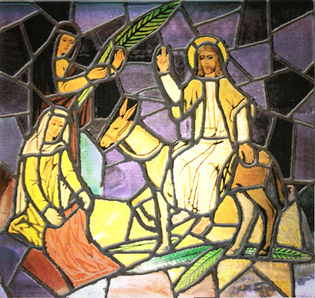

Palm Sunday
Holy Communion.

The Greeting
The president greets the people and says:

Hosanna to the Son of David, the King of Israel. Blessed is he who comes in the name of the Lord. Hosanna in the highest.

Blessing the palm
The People hold up their palms while the prayer is being said

God our Saviour,
whose Son Jesus Christ entered Jerusalem as Messiah to suffer and to die; let these palms be for us signs of his victory and grant that we who bear them in his name may ever hail him as our King,
and follow him in the way that leads to eternal life; who is alive and reigns with you, in the unity of the Holy Spirit,
one God, now and for ever.
All Amen.

Palm Gospel Reading:
Matthew 21: 1-11

All Glory to you, O Lord.

This is the Gospel of the Lord.
All Praise to you, O Christ.

Hymn: Hosanna, Hosanna in the highest x1
Majesty worship his majesty x1

The Collect: (on readings & news sheet)
All: Amen.

Readings:
Philippians 2:5-11

This is the word of the Lord.
All: Thanks be to God.

Talk.

Prayers:

The Peace
Introduction to the Peace,
Once we were far off,
but now in union with Christ Jesus
we have been brought near
through the shedding of Christ’s blood,
for he is our peace.

The peace of the Lord be with you
All: and also with you.

Let us offer one another a sign of Christ’s peace.

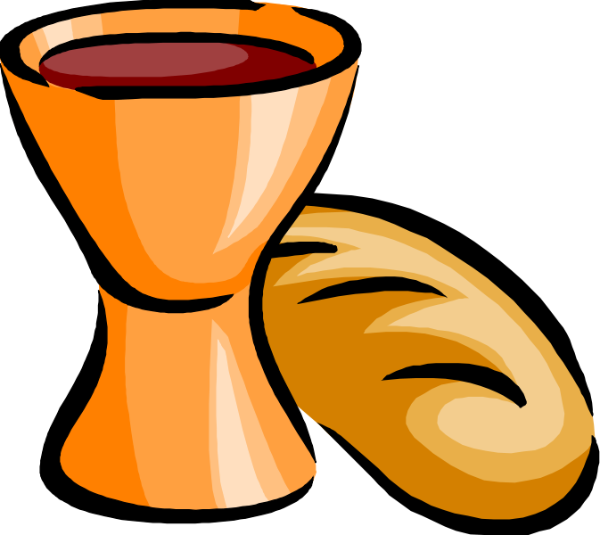
The Eucharistic Prayer

The Lord is here.
His Spirit is with us.

Lift up your hearts.
We lift them to the Lord.

Let us give thanks to the Lord our God.
It is right to give you thanks and praise.

It is indeed right and just, our duty and our salvation, always and everywhere to give you thanks, holy Father, almighty and eternal God, through Jesus Christ our Lord. For as the time of his passion and resurrection draws near the whole world is called to acknowledge his hidden majesty.

The power of the life-giving cross reveals the judgement that has come upon the world and the triumph of Christ crucified. He is the victim who dies no more, the Lamb once slain, who lives for ever, our advocate in heaven to plead our cause, exalting us there to join with angels and archangels, for ever praising you and saying:

Holy, holy, holy Lord,
God of Power and might,
Heaven and earth are full of your glory.
Hosanna in the highest.

We praise and bless you, loving Father through Jesus Christ, our Lord; and as we obey his commandment, send your Holy Spirit, that broken Bread and wine outpoured may be for us the body and blood of your dear Son. On the night before he died he had supper with his friends and, taking bread, he praised you. He broke the bread, gave it to them and said: Take eat; this is my body which is given for you; do this in remembrance of me. When supper was ended he took the cup of wine. Again he praised you, gave it to them and said: Drink this all of you; this is my blood of the new covenant, which is shed for you and for many for the forgiveness of sins. Do this, as often as you drink it, in remembrance of me. So, Father, we remember all that Jesus did, in him we plead with confidence his sacrifice made once for all upon the cross. Bringing before you the bread of life and the cup of salvation, we proclaim his death and resurrection until he comes in glory. Great is the mystery of faith:

Christ has died, Christ has risen,
Christ will come again.

Lord of all life help us to work together for that day when your kingdom comes and justice and mercy will be seen in all the earth. Look with favour on your people, gather us in your loving arms and bring us with all the saints to feast at your table in heaven. Through Christ, and with Christ, and in Christ in the unity of the Holy Spirit, All honour and glory are yours,
O loving Father, forever and ever. Amen

As our Saviour taught us, so we pray:

ALL: Our Father who art in heaven,
hallowed be thy name,
thy kingdom come;
thy will be done;
on earth as it is in heaven.
Give us this day our daily bread.
And forgive us our trespasses,
as we forgive those who
trespass against us.
And lead us not into temptation
but deliver us from evil.
For thine is the kingdom, the power,
and the glory, for ever and ever.
Amen.

Breaking of the Bread

We break this bread
To share in the body of Christ.

Though we are many, we are one body,
Because we all share in one bread.

Prayer after Communion

All: Almighty God, we thank you for feeding us with the body and blood of your Son Jesus Christ. Through him we offer you our souls and bodies to be a living sacrifice. Send us out in the power of your Holy Spirit to live and work to your praise and glory.
Amen

Notices:

Final Hymn: Ride on, ride on in Majesty
(Verses 1 & 5 only)

Blessing and Dismissal

May God, who gave birth to all creation, bless us: may God, who became incarnate by an earthly mother, bless us: may God, who broods as a mother over her children, bless us. May almighty God bless us, Father, Son and Holy Spirit, now and forever.
All: Amen.

Go in peace to love and serve the Lord.
All: In the name of Christ. Amen.

