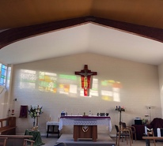
The Church of The Annunciation 2022

Dear all,

Happy new year!
We do hope 2022 has begun without too many curve balls to manage!
Though we’re not living in lockdown like this time last year, we’ve still been experiencing the ongoing impact of the pandemic, managing the changing landscape of do’s and don’ts.

However, through these unpredictable times we continue to hold onto the truth that God is our God in every season, good and bad.

Let’s look at a few of 2021’s highlights:

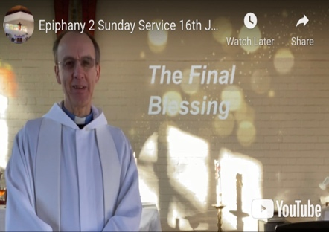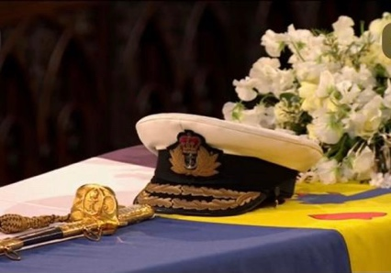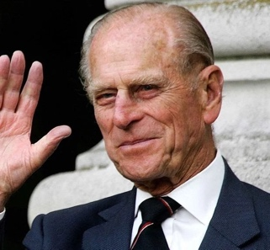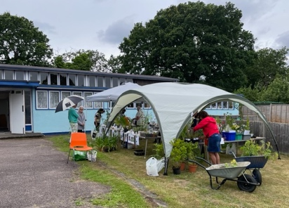
Services continued online. We bade farewell to Prince Philip. Re-started coffee Mornings with a plant sale.

We enjoyed a hobby focussed coffee morning among other programme ‘plus’ moments….
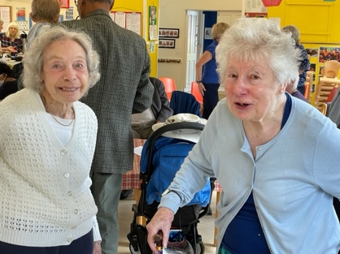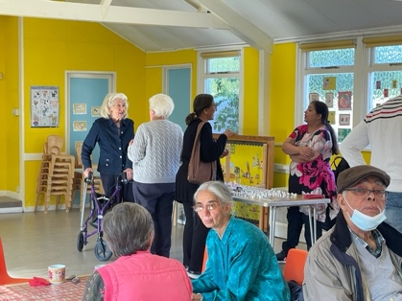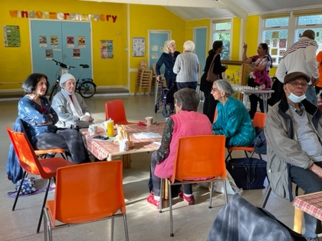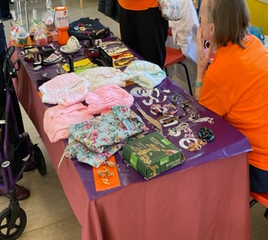
Our dear friends Joan and June have been able to visit coffee mornings regularly. We’ve supported friends raising money for charity too.

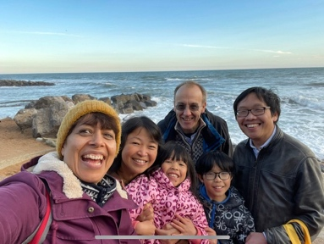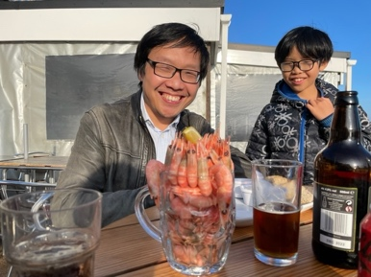
The Goddard’s and the Siow’s bumped into each other in the Isle of Wight on May’s birthday and enjoyed a pint of prawns up close!
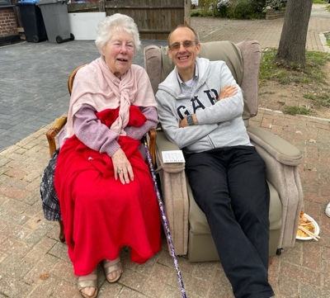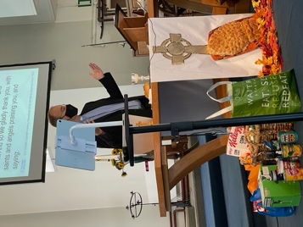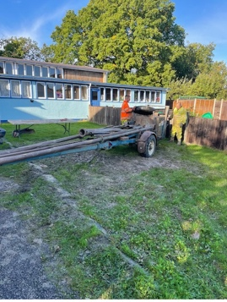
Our dear Ann made the move into a nursing home and is being well looked after there.
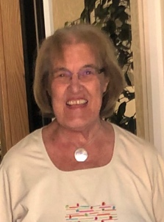
And we had an exciting site dig to find out about the soil as part of initial planning work in the long journey to improving our church building – one step at a time.

There was a lovely street party in Rydall Gardens and June was able to sit out and enjoy it!
Trevor was licensed at St Cuthbert’s in October and so is now vicar of two parishes!
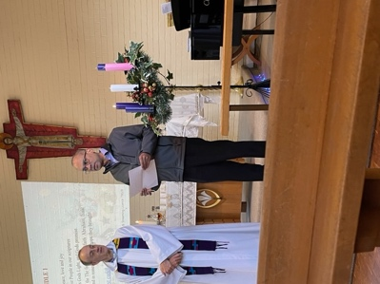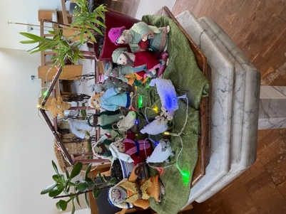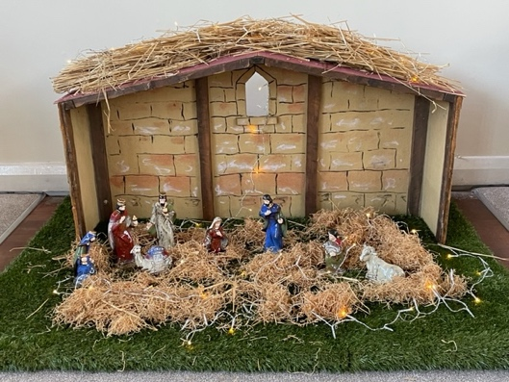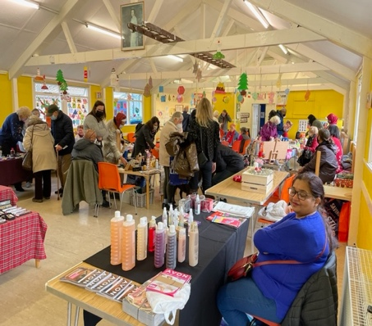
All too quickly the season of Advent dawned. And the season of Christmas fair Coffee mornings and carolling was enjoyed by all, supported by a very successful joint community choir drawn from the two churches and neighbourhoods!

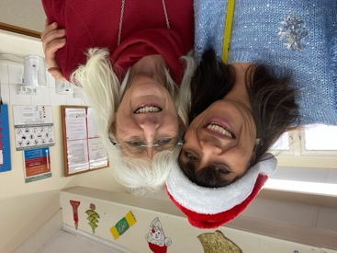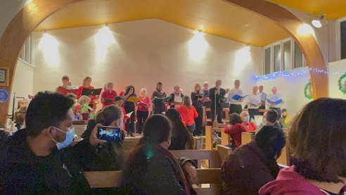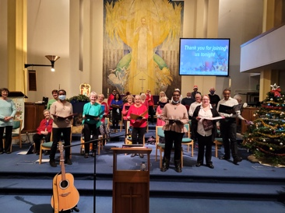

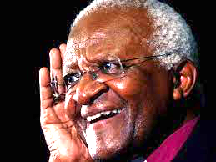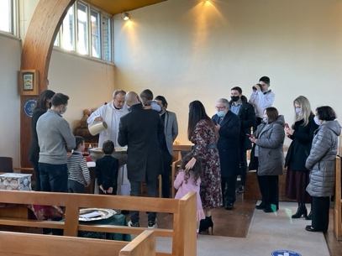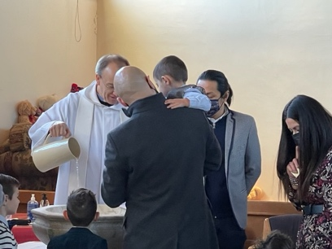
Across the globe we all said a heart-warming and sad farewell on Xmas Eve to one of faith’s giants, with the passing of Bishop Desmond Tutu.

In the beginning of January, we had the joy of baptising Apollo Dominguez–
Marianna’s second grandchild of parents, Luis and Amelia, having baptised Xander a few years before at this time of year.
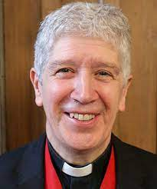
And of course, Jeremy has always been on hand to help cover Trevor in holiday season with great determination as he has battled against all the train stoppages and cancelations!
One Sunday the challenge was so great that coffee was moved to the start of the morning rather than the end. But Jeremy battled on and made it, bless him!
Made for an unusual and fun Sunday together.

Recently, as we’ve met together as a church community, face-to-face or online, we have been reflecting on the truth that God is always calling us – as individuals and as a community.
What might God be calling you to this year?
Sometimes we can think that if we’re not able to do much we aren’t of much value. But as Trevor always says, our value is inherent in our very presence – we bring great value to the lives of others by just being ourselves as we reflect Christ’s light in our community – being present in every way we can be.

It is our prayer that people are able to discover or rediscover faith and thrive in their relationship with God. Jesus said ‘I have come that they might have life – life in all it’s fulness.’
The PCC of both The Annunciation and St Cuthbert’s have recently met to think about the stories of our past, what we’re doing now and what we need to be doing as we move forward. What have you loved about being part of our church community? If it’s warmed your heart, it’s probably warmed others too. Have you got ideas, things you’d like to give a try? Have a chat with your vicar. Trevor is happy for anyone to give things a go – nothing ventured, nothing gained.

As we once again step back into more freedom, it will be great to see more people, as they are able, come and be part of live worship and live events as they happen. We are praying that people will be able to consider how much they can feel involved as we move into 2022.

We want our church family to be a warm community - to welcome people, helping them find a place to belong and to find friendship and faith. We pray that where possible you will be part of that welcome, sharing those acts of kindness and sweating the small stuff that can be so important for so many.

As we make a journey along another year, may we all continue to know God’s healing, his friendship, his strength, his comfort, his soothing voice and the joy of his hope in all life’s uncertainties.

May we know his deep joy as we serve our God and each other.

With our love and prayers,

Trevor & Jacqui

PS: Why not join us for our next coffee morning at The Annunciation:
Saturday 12th February 2022 between 10.00am and 12.00pm

Service times for the two churches are:

The Annunciation: 9.30am

St Cuthbert’s: 11.00am

Websites:

The Annunciation: southkentonchurch.org

St Cuthbert’s: stcuths.org

Contact Trevor: 020 8908 2252 (If no answer please leave a message)

